Medicine Monitoring System


 | Prepared By / Last Updated By | Reviewed by | Approved By
Name | Nitin Verma | Payush | Parth Sharma
Role | Team Member | Team Member | Scrum Master
Signature
Date

Table of Contents
1.0 Introduction 4
1.1 Purpose & Scope of the document 4
1.2 Intended Audience 4
1.3.1 Use case ‘Admin Registration’ 4
1.2.1 Use case attributes 4
1.2.2 Use Case Model 5
1.2.3 Business Rules 5
1.2.4 UI Requirements 6
1.2.5 UI Field Validations 7
1.3 Use case ‘Admin Credential Authentication' 7
1.3.1 Use case attributes 7
1.3.2 Use Case Model 8
1.3.3 Business Rules 8
1.3.4 UI Requirements 9
1.3.5 UI Field Validation 9
1.4 Use Case ‘Branch Admin Details’ 9
1.4.1 Use case attributes 9
1.4.2 Use Case Model 11
1.4.3 Business Rules 11
1.4.4 UI Requirements 12
1.5 Use case ‘Branch Admin registration’ 12
1.5.1 Use case attributes 12
1.5.2 Use Case Model 13
1.5.3 Business Rules 13
1.5.4 UI Requirements 14
1.5.5 UI Field Validations 14
1.6 Use case ‘Edit Branch Admin Details’ 14
1.6.1 Use case attributes 14
1.6.2 Use case Model 15
1.6.3 Business Rules 16
1.6.4 UI Requirements 16
1.6.5 UI Field Validations 16
1.7 Use case ‘Medicine Information’ 16
1.7.1 Use case attributes 16
1.7.2 Use Case Model 17
1.7.3 Business Rules 18
1.7.4 UI Requirements 18
1.8 Use Case ‘Add Medicine’ 18
1.8.1 Use Case Attributes 18
1.8.2 Use Case Model 20
1.8.3 Business Rules 20
1.8.4 UI Requirements 21
1.8.5 UI Validations 21
1.9 Use Case ‘Edit Medicine Details’ 21
1.9.1 Use Case Attributes 21
1.9.2 Use Case Model 22
1.9.3 Business Rules 23
1.9.4 UI Requirements 23
1.9.5 UI Validations 23
1.10 Use Case ‘Update Medicine Stock’ 23
1.10.1 Use case attributes 23
1.10.2 Use Case model 25
1.10.3 Business Rules 25
1.10.4 UI Requirements 25
1.10.5 UI Field Validations 25
1.11 Use Case ‘Create branch Admin Request’ 26
1.11.1 Use Case Attributes 26
1.11.2 Use Case Model 27
1.11.3 Business Rules 27
1.11.4 UI Requirements 28
1.11.5 UI Field Validations 28
1.12 Use Case ‘Update Branch Admin Request’ 28
1.12.1 Use Case attributes 28
1.12.2 Use Case Model 29
1.12.3 Business Rules 29
1.12.4 UI Requirements 30
1.12.5 UI Field validation 30
2.0 Database Design 30
2.1 Tables Structure 30
3.0 Change Log 33

Introduction

Purpose & Scope of the document

The purpose of this use case document is to collectively gather and capture all the business requirements of the project and the system to be developed in terms of use cases in a systematic timely manner. This document deals with functional use cases in a non-functional perspective manner. It also serves as the input for the project scoping.

The scope of this document is limited to addressing the use cases from the Admin, quality, and non-functional perspective.

Intended Audience
Each member of the project team including project mentor.

1.3.1 Use case ‘Admin Registration’

Use case attributes
Use Case Description:

This use case deals with the capture of Admin details through registration process. The ‘Admin’ here shall be the operator of the system and will be responsible for handling all the operations related to branch Admin and Medicine Directory Management.

Scope:

- Admin registration

Actors:

- Admin– the operator

Trigger:

Click ‘Register’ button in the ‘Admin Registration’ page

Pre-Condition:

Admin being able to access the homepage & get redirected to the ‘Admin Registration’ page upon click of ‘Register ‘link.

Post Condition:

Admin is in the registration page & submit details

Flow of Events:

Admin at homepage → Click ‘Register ‘link → Admin is in the registration page → Admin details are submitted and added onto the database

Primary Scenario:
A new Admin– is able to click ‘Register ‘ link and able to provide his details and get enrolled in the system.

Use Case Model
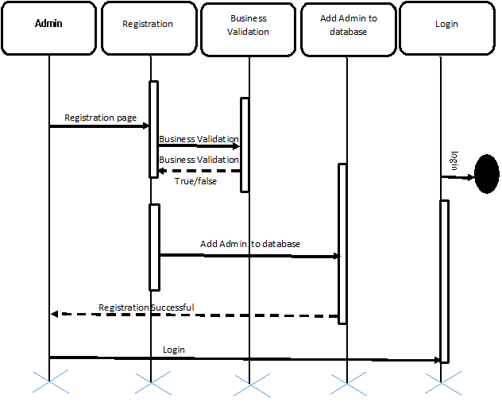

Business Rules

- When the Admin clicks on the registration link, it should re-direct to registration form.
    - Admin needs to fill some of the basic attributes/fields as mentioned below in requirement: First Name, Last Name, Age, Gender, Contact Date of Birth, Admin Id, Password
- Clicking ‘Submit’ should validate the datatype constraints for each field
- Post-successful field level validation, save the information in the database
- Upon saving the information in the database, display the message ‘Your details are submitted successfully’.

UI Requirements



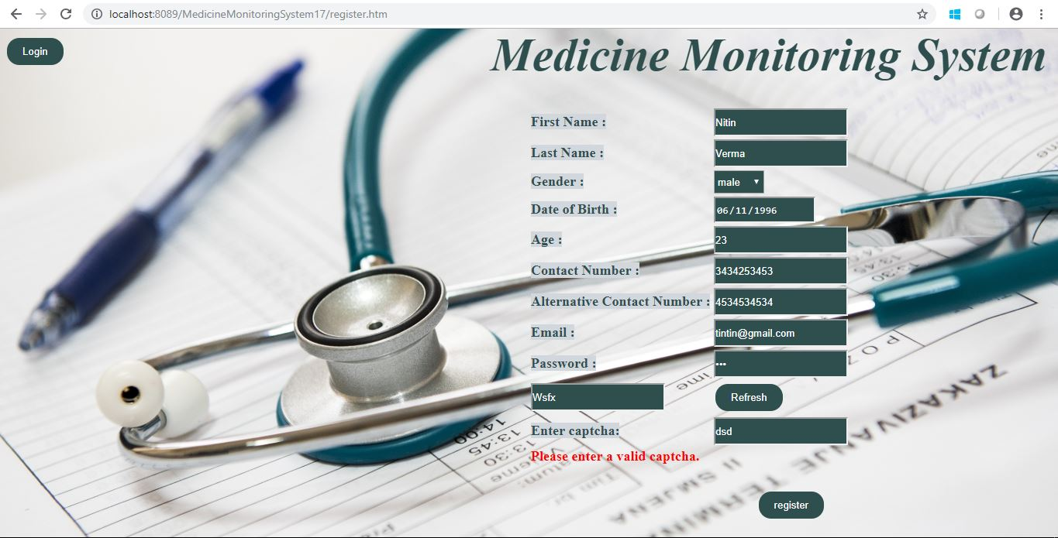

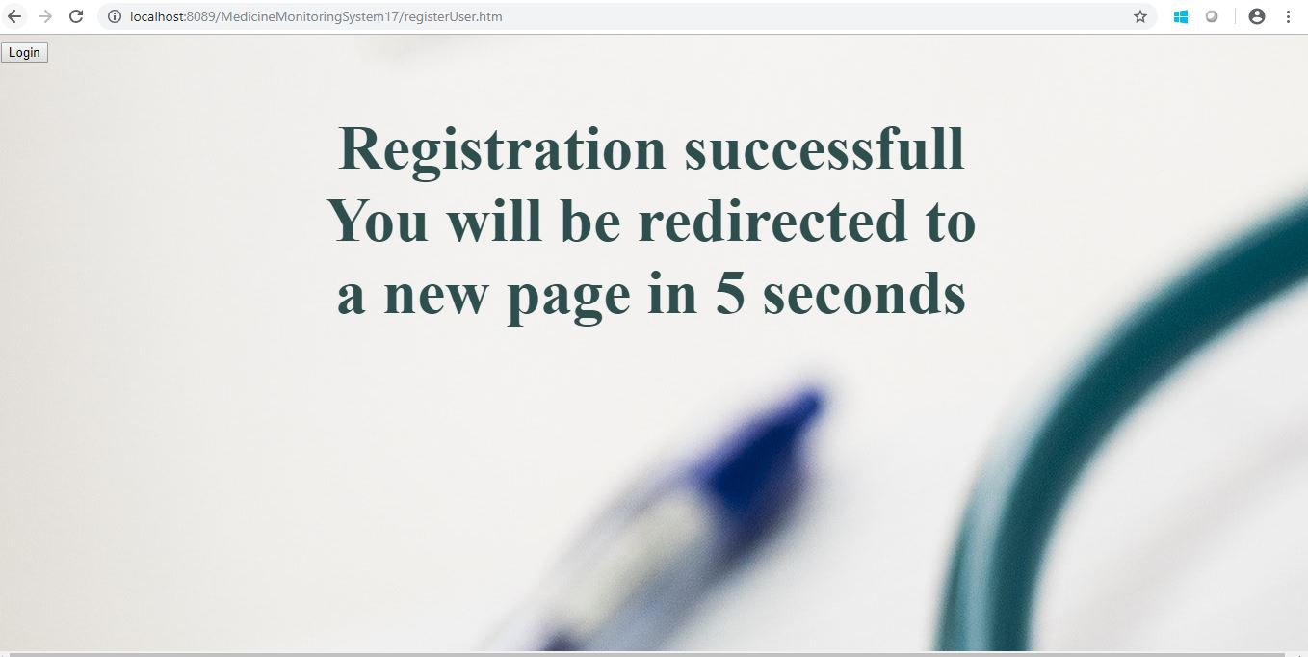

UI Field Validations

- All fields are mandatory except Alternate Contact number.
- Admin should be less than 10 chars. Password should have maximum length 10 chars & can contain special characters (ex.!,@,#,%,*,& etc.)
- The Email ID format must be checked. (For ex. abc@gmail.com.)
- Phone Number must be of 10 digits’ length.

Use case ‘Admin Credential Authentication'

Use case attributes
Use Case Description:

This use case deals with the authentication of the admin credentials. The ‘Admin’ here shall be the operator of the system and will be managing all the operations related to branch admin and medicine stocks.

Scope:

- Admin credentials authentication/Admin Login

Actors:

Admin– the operator

Trigger:

Click ‘Login’ link, after keying in ‘AdminID’ & ‘Password’ field.

Pre-Condition:

Admin being able to access the homepage

Post Condition:

Admin is in the Home page where he/she can perform all the operations authorized to him/her.

Flow of Events:

Admin at Login Page → Key in ‘AdminID’ & ‘Password’ field → Admin credentials are validated Admin home page is displayed

Primary Scenario:
A registered Admin – is able click ‘Login’ link, after keying in ‘AdminID’ & ‘Password’ field and get his/her credentials authenticated with the existing database entry.

Alternative Scenario:
A registered Admin – is able click ‘Login’ link, after keying in ‘AdminID’ & ‘Password’ field and unable to get his credentials authenticated. The Admin is presented with relevant error messages:

- Invalid Admin ID – ‘The adminid provided does not exist in our records’
- Incorrect Password – ‘Password provided is incorrect’

Use Case Model
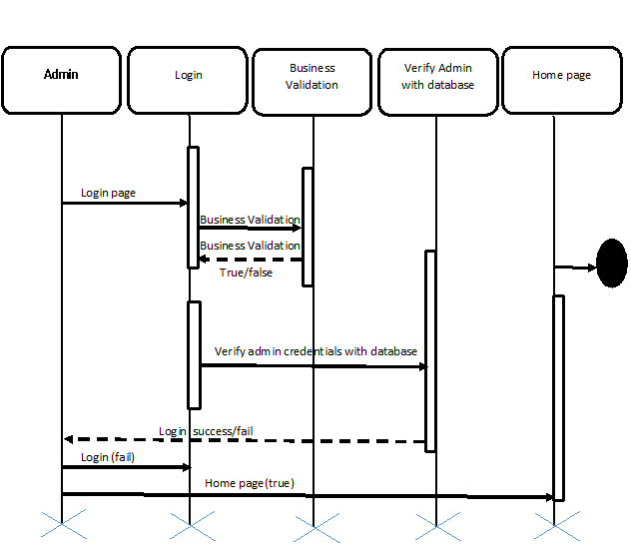

Business Rules
Business rules should be defined using the following attributes:-

- A registered Admin – is able click ‘Login’ link, after keying in ‘AdminID’ & ‘Password’ field and get his credentials authenticated with the existing database entry.
- Post successful authentication admin should get redirected to its respective home page.

UI Requirements



UI Field Validation
- Password field must be of type password

Use Case ‘Branch Admin Details’

Use case attributes
Use Case Description:

This use case deals with the display of branch admin details. The ‘Admin’ here shall be the operator of the system and will be able to view all registered branch admin details and detailed view of branch admin by clicking on branch Admin ID link of individual branch Admin .

Scope:

- Branch Admin Details

Actors:

Admin– the operator

Trigger:

Click ‘branch Admin’ button in Admin home page after admin login.

Pre-Condition:

Admin being able to access its own home page.

Post Condition:

Admin is in its own Home page where he/she is able to view all the registered branch admin details and is able to view specific branch admin details on clicking the ‘branchAdminID’ link of individual branch Admin.

Flow of Events:

Admin at Home Page →Admin clicks on ‘Branch Admin’ link → Admin is in the Branch Admin details page → Admin clicks on branch Admin ID→Admin is in the details page of specific branch Admin

Primary Scenario:
A registered Admin – is able to click on ‘Branch Admin’ link in the admin home page and is able to view the all registered branch admin details in the branch Admin Home page and specific view can be generated by clicking on branch Admin Id of individual branch Admin.

Use Case Model
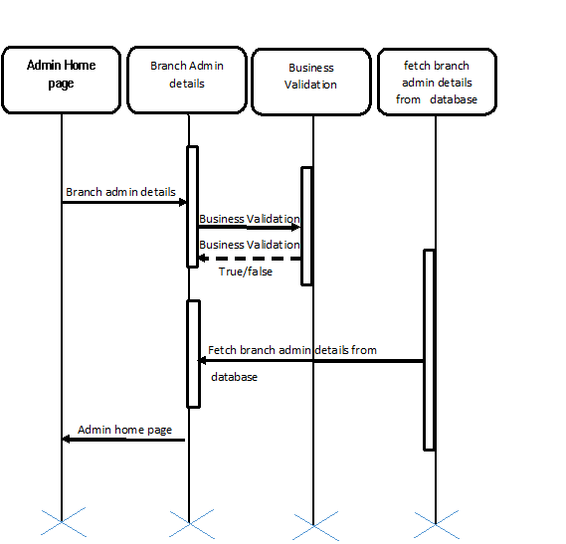

Business Rules

- A registered Admin is able click ‘Branch Admin’, in Admin home page/session and is able to view all the registered branch Admin details in branch Admin home page.
- Admin should also be able to view specific branch admin details by clicking on ‘branchAdminId’ of specific branch admin in branch admin home page.

UI Requirements

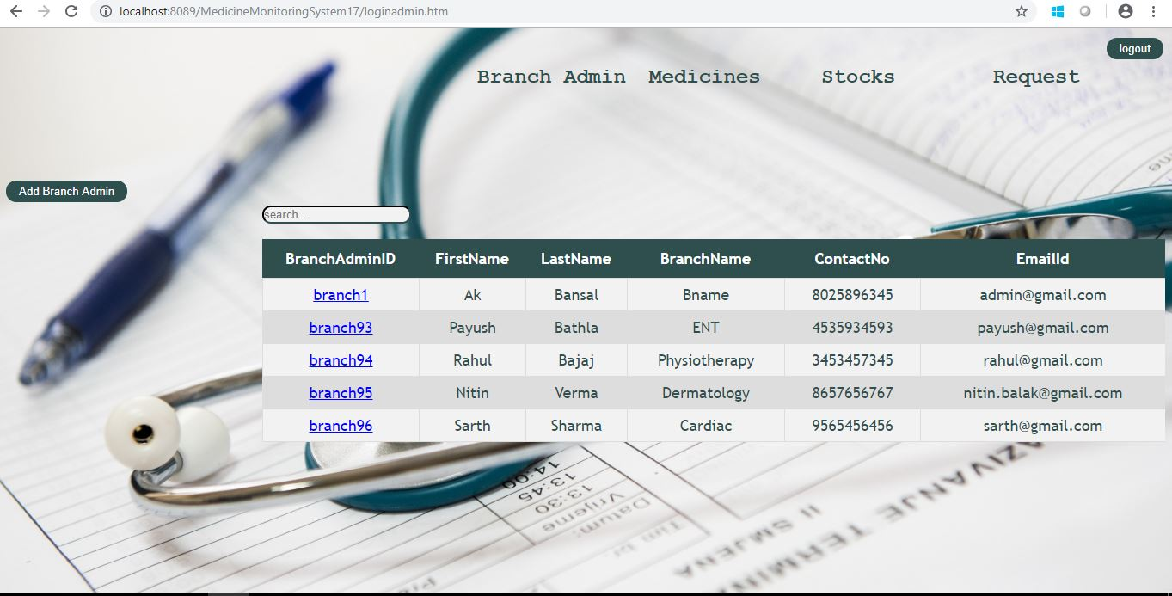

Use case ‘Branch Admin registration’

Use case attributes

Use Case Description:

This use case deals with the registration of branch admin. The ‘Admin’ here shall be the operator of the system and will be registering/adding new branch admin.

Scope:

- Branch Admin Registration

Actors:

Admin– the operator

Trigger:

Click ‘Add branch Admin’ button in Branch Admin details page after admin login.

Pre-Condition:

Admin being able to access its own home page.

Post Condition:

Admin is in its own Home page where he/she can add new branch Admin.

Flow of Events:

Admin at Home Page →Admin clicks on ‘Branch Admin’ link→ Admin clicks on ‘Add Branch Admin’ link → Admin is in the Branch Admin creation page →Branch Admin details are submitted and added onto the database→success message.

Primary Scenario:
A registered Admin – is able click ‘ Add Branch Admin’ link in the branch admin details page and is able to register a new Branch Admin by clicking on ‘Add Branch Admin’ link post successful validation.

Use Case Model
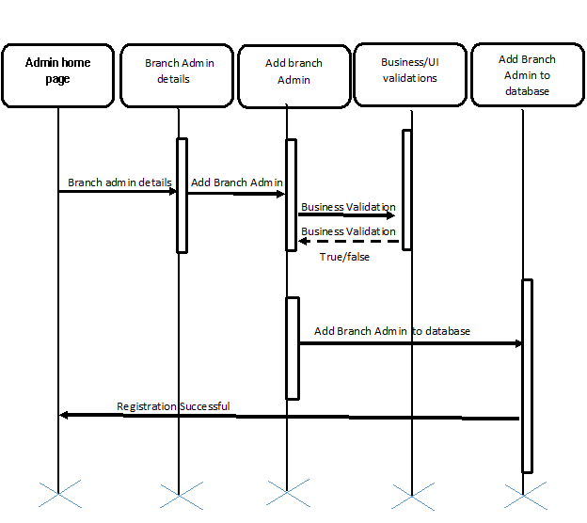

Business Rules
Business rules should be defined using the following attributes:-

- A registered Admin is able click ‘ Add Branch Admin, in branch Admin home page/session and is able to update all the necessary fields..
- Branch Admin Id should be auto-generated and should be alphanumeric and should have maximum length 10.
- Clicking ‘Submit’ should validate the datatype constraints for each field
- Post-successful field level validation, save the information in the database
- Upon saving the information in the database, display the message ‘Your details are submitted successfully’.

UI Requirements

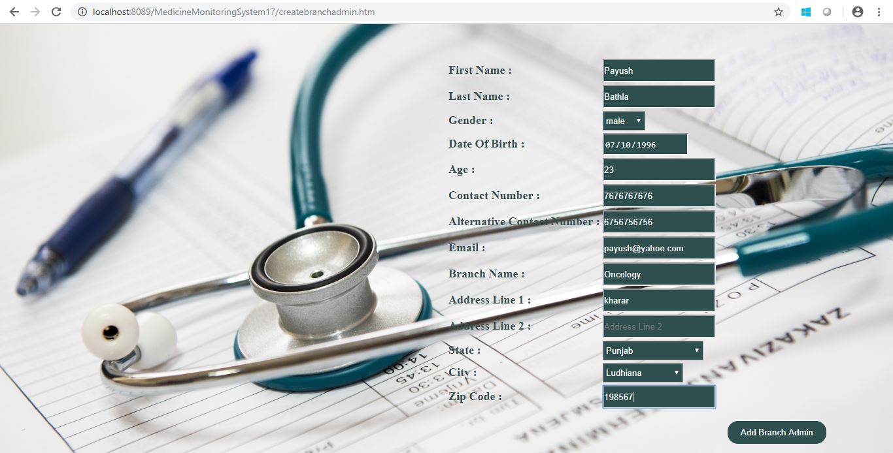

UI Field Validations
- All fields are mandatory except Alternate Contact number.
- Admin should be less than 10 chars. Password should have maximum length 10 chars & can contain special characters (ex.!,@,#,%,*,& etc.)
- The Email ID format must be checked. (For ex. abc@gmail.com.)
- Phone Number must be of 10 digits’ length.
- State and city should contains only characters
- Age should be number >=18;
- Zip code field length should be 6 and should contain only numbers.

Use case ‘Edit Branch Admin Details’

Use case attributes
Use Case Description:

This use case deals with the editing of branch admin details. The ‘Admin’ here shall be the operator of the system and will be able to edit all registered branch admin details by clicking on branch Admin ID link of individual branch Admin followed by ‘edit’ link in the following page.

Scope:

- Editing Branch Admin details

Actors:

Admin– the operator

Trigger:

Click ‘Edit’ button in Branch Admin home page.

Pre-Condition:

Admin being able to access its own home page followed by branch Admin home page.

Post Condition:

Admin is in its own Home page where he/she is able to view all the registered branch admin details in branch Admin Home page and is able to edit specific branch admin details on clicking the branchAdmin ID link of individual branch Admin followed by clicking on the ‘edit’ link.

Flow of Events:

Admin at Home Page →Admin clicks on ‘Branch Admin’ link → Admin is in the Branch Admin details page → Admin clicks on branch Admin ID→Admin is in the details page of specific branch Admin→Admin clicks on ‘edit’ link→Admin is in the edit page of Branch Admin. →Admin clicks on ‘update’ link→Admin is in branch Admin home page.

Primary Scenario:
A registered Admin – is able to click on ‘Branch Admin’ link in the admin home page and is able to view the all registered branch admin details in the branch Admin details page and editing of specific branch admin details can be done by clicking on ’branchAdminId’ link of specific branch admin followed by clicking on ‘edit’ link on branch Admin home page further Admin would be redirected to the edit page of branch admin where he/she can edit details of branch admin and click ‘Update’ link to submit the updated details to the database post successful validation.

Use case Model
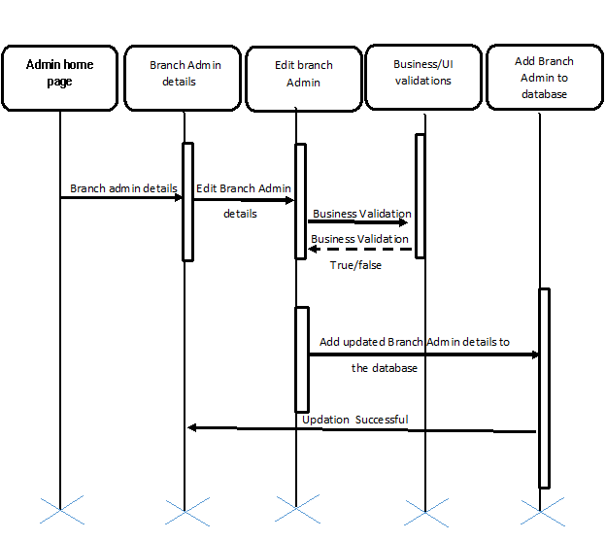

Business Rules
- A registered Admin – is able click ‘Branch Admin’, in Admin home page/session and is able to view all the registered branch Admin details in branch Admin home page.
- Admin should be able to edit specific branch admin details by clicking on ‘branchAdminId’ of specific branch admin in branch admin home page followed by clicking ‘edit’ link on next page.
- Admin should be able successfully submit the updated details post successful validation with message ‘Details updated successfully’.
- Admin should be redirected to branch Admin details page post successful updation of branch Admin details.

UI Requirements

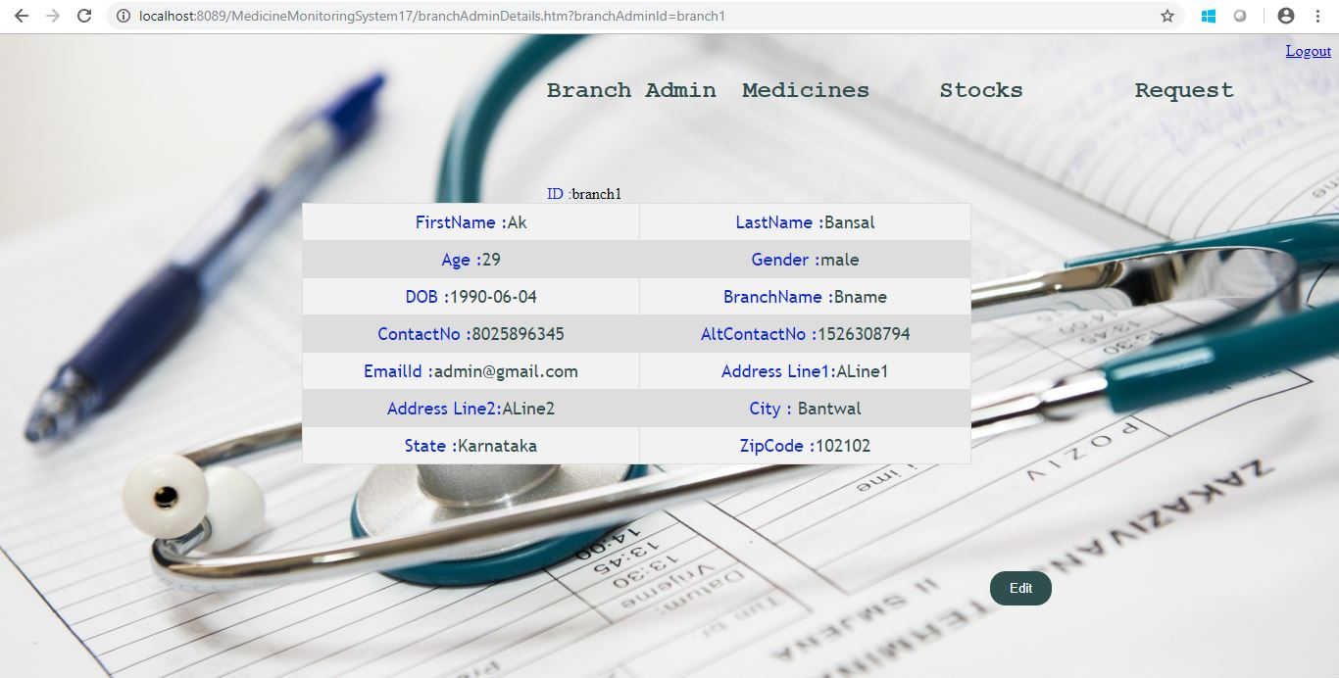

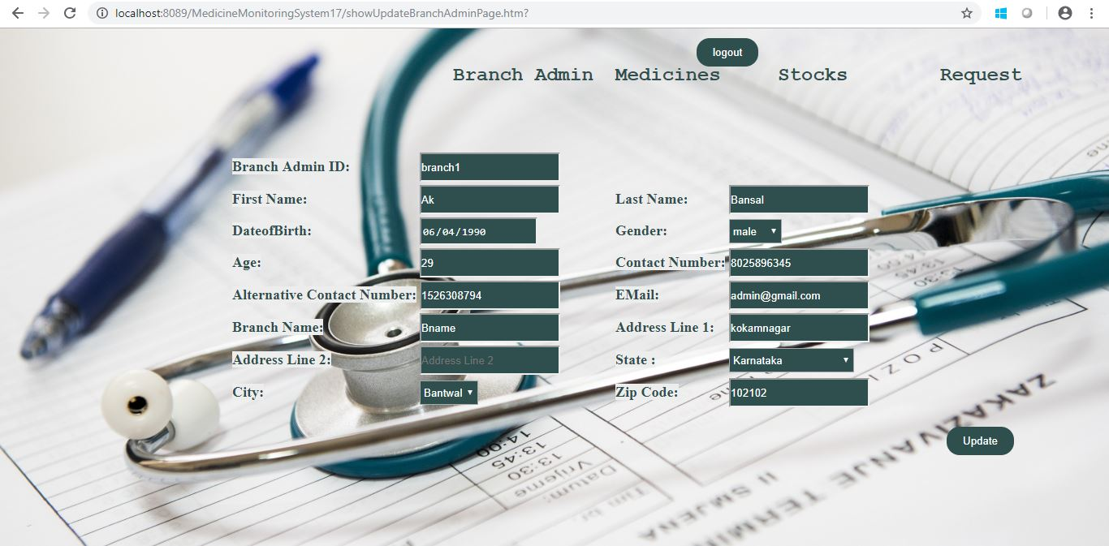

UI Field Validations
- All fields are mandatory except Alternate Contact number.
- Admin should be less than 10 chars. Password should have maximum length 10 chars & can contain special characters (ex.!,@,#,%,*,& etc.)
- The Email ID format must be checked. (For ex. abc@gmail.com.)
- Phone Number must be of 10 digits’ length.
- State and city should contain only characters
- Age should be number >=18;
- Zip code should be of length 6 and should contain only numbers.

Use case ‘Medicine Information’

Use case attributes
Use Case Description:

This use case deals with the display list of all available medicine details. The ‘Admin’ here shall be the operator of the system and will be able to view all available medicine details and detailed view of each medicine by clicking on medicine ID link of individual medicine .

Scope:

- Medicine Details

Actors:

Admin– the operator

Trigger:

Click ‘medicine Information’ button in Admin home page after admin login.

Pre-Condition:

Admin being able to access its own home page.

Post Condition:

Admin is in its own Home page where he/she is able to view all available medicine details and is able to view specific medicine detail on clicking the ‘medicineID’ link of individual branch Admin.

Flow of Events:

Admin at Home Page →Admin clicks on ‘Medicine Information’ link → Admin is in the medicine details page → Admin clicks on medicine ID→Admin is in the details page of specific medicine

Primary Scenario:
A registered Admin – is able to click on ‘medicine information’ link in the admin home page and is able to view the all available medicine details in the medicine details page and specific view can be generated by clicking on medicine Id of individual Medicine.

Use Case Model

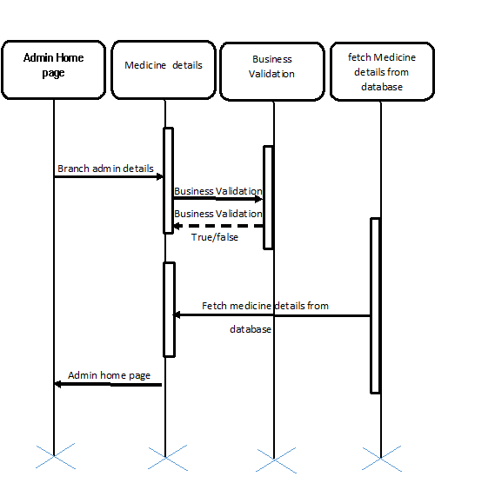

Business Rules
- A registered Admin is able click ‘Medicine Information’, in Admin home page/session and is able to view all available medicine details in the medicine details page.
- Admin should also be able to view specific branch admin details by clicking on ‘branchAdminId’ of specific branch admin in branch admin home page.

UI Requirements

Use Case ‘Add Medicine’

Use Case Attributes
Use Case Description:

This use case deals with addition of new medicine in the inventory. The ‘Admin’ here shall be the operator of the system and will be adding new medicine in the database.

Scope:

- Add medicine

Actors:

Admin– the operator

Trigger:

Click ‘Add medicine’ button in Medicine details page .

Pre-Condition:

Admin being able to access its own home page.

Post Condition:

Admin is in its own Home page where he/she can add new Medicine.

Flow of Events:

Admin at Home Page →Admin clicks on ‘Medicine Information’ link→ Admin clicks on ‘Add Medicine’ link → Admin is in the Medicine creation page →Medicine details are submitted and added onto the database→success message.

Primary Scenario:
A registered Admin – is able click ‘ Add Medicine’ link in the medicine details page and is able to new medicine by clicking on ‘Add medicine’ link post successful validation.

Use Case Model
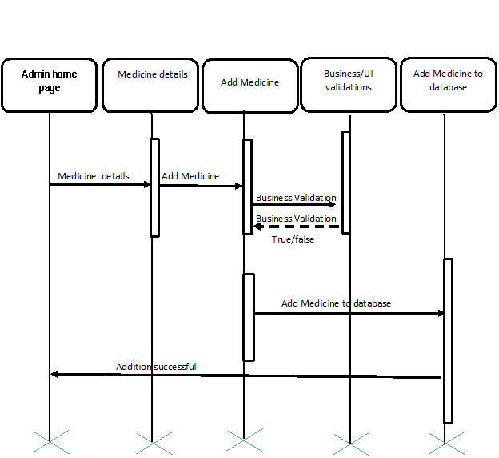

Business Rules
- A registered Admin is able click ‘Add Medicine, in medicine details page/session and is able to update all the necessary fields.
- Medicine Id should be auto-generated and should be numeric and should have maximum length 10.
- Clicking ‘Submit’ should validate the datatype constraints for each field
- Post-successful field level validation, save the information in the database
- Upon saving the information in the database, display the message ‘Your details are submitted successfully’.

UI Requirements

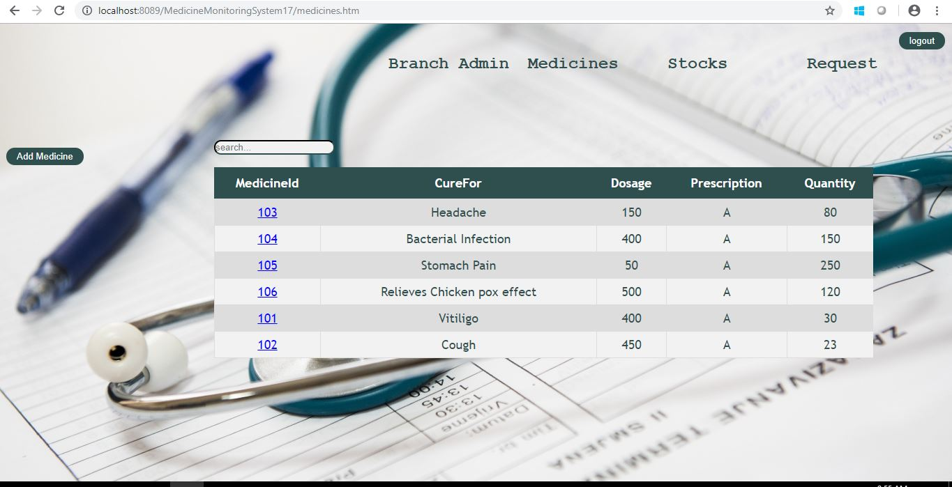

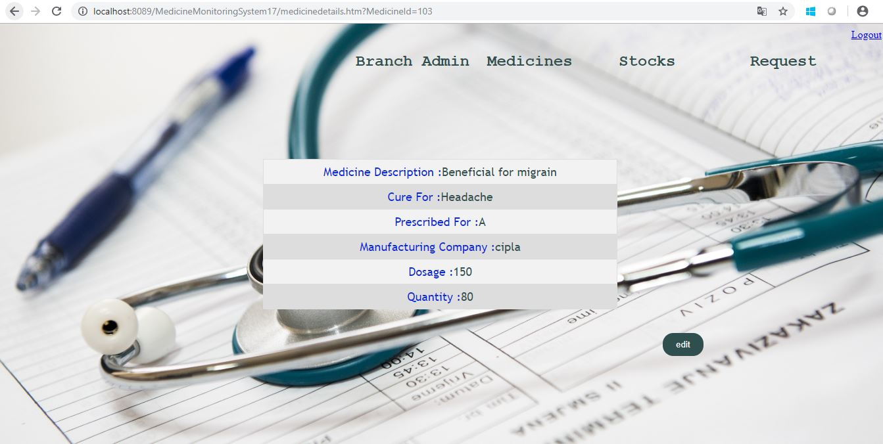

UI Validations
- All fields are mandatory .
- Dosage should be numeric having maximum length 3.
- Prescribed for: field should be either ‘A’(adult) or ‘C’(child) only.
- Medicine description should be of max 200 chars.

Use Case ‘Edit Medicine Details’

Use Case Attributes
Use Case Description:

This use case deals with editing of medicine details. The ‘Admin’ here shall be the operator of the system and will be able to edit all available medicine details by clicking on medicine ID link of individual medicine followed by ‘edit’ link in the following page.

Scope:

- Editing Medicine details

Actors:

Admin– the operator

Trigger:

Click ‘Edit’ button in Medicine Information page.

Pre-Condition:

Admin being able to access its own home page followed by Medicine information page.

Post Condition:

Admin is in its own Home page where he/she is able to view all available medicine details in medicine information page and is able to edit specific medicine details on clicking the medicine ID link of individual medicine followed by clicking on the ‘edit’ link.

Flow of Events:

Admin at Home Page →Admin clicks on ‘Medicine information’ link → Admin is in the Medicine details page → Admin clicks on Medicine ID→Admin is in the details page of specific Medicine→Admin clicks on ‘edit’ link→Admin is in the edit page of medicine. →Admin clicks on ‘update’ link→success message→Admin is in medicine information page.

Primary Scenario:
A registered Admin – is able to click on ‘Medicine Information’ link in the admin home page and is able to view all the available list of medicines in the medicine information page and editing of specific medicine details can be done by clicking on ’MedicineId’ link of specific medicine followed by clicking on ‘edit’ link , further Admin would be redirected to the edit page of medicine where he/she can edit details of medicine and click ‘Update’ link to submit the updated details to the database post successful validation.

Use Case Model
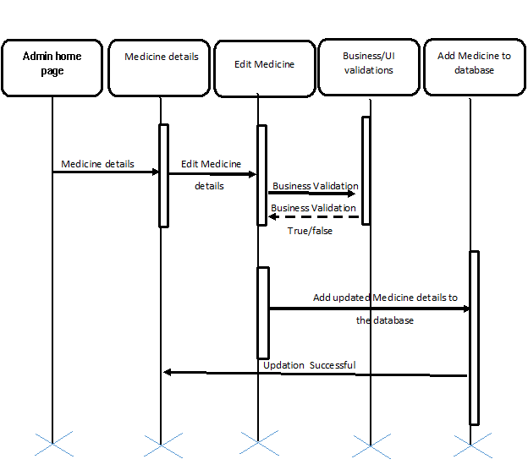

Business Rules
- A registered Admin – is able click ‘Medicine information’ link in Admin home page/session and is able to view all the available medicine details in medicine information page.
- Admin should be able to edit specific medicine details by clicking on ‘MedicineId’ of specific Medicine in medicine information page followed by clicking ‘edit’ link on next page.
- Admin should be able successfully submit the updated details post successful validation with message ‘Details updated successfully’.
- Admin should be redirected to medicine details page post successful updation of medicine details.

UI Requirements



UI Validations
- All fields are mandatory.
- Dosage should be numeric having maximum length 3.
- Prescribed for: field should be either ‘A’(adult) or ‘C’(child) only.
- Medicine description should be of max 200 chars.

Use Case ‘Update Medicine Stock’

Use case attributes
Use Case Description:

This use case deals with updation of medicine stocks. The ‘Admin’ here shall be the operator of the system and will be able to update stocks of all available medicines by clicking on medicine ID link of individual medicine followed by ‘edit’ link.

Scope:

- Updating Medicine Stocks.

Actors:

Admin– the operator

Trigger:

Click ‘Edit’ button in Medicine Stock Information page.

Pre-Condition:

Admin being able to access its own home page followed by Medicine Stock information page.

Post Condition:

Admin is in its own Home page where he/she is able to view all available medicine details in medicine stock information page by clicking ‘update Stock’ link and is able to edit specific medicine stock on clicking the medicine ID link of individual medicine followed by clicking on the ‘edit’ link.

Flow of Events:

Admin at Home Page →Admin clicks on ‘Update Medicine Stocks’ link → Admin is in the Medicine Stock details page → Admin clicks on Medicine ID→Admin is in the stock details page of specific Medicine→Admin clicks on ‘edit’ link→Admin is in the edit page of medicine stock. →Admin clicks on ‘update’ link→success message→Admin is in medicine information page.

Primary Scenario:
A registered Admin – is able to click on ‘Update medicine stock’ link in the admin home page and is able to view all the stocks of available list of medicines in the medicine stock information page and editing of specific medicine stock details can be done by clicking on ’MedicineId’ link of specific medicine followed by clicking on ‘edit’ link , further Admin would be redirected to the edit page of medicine stocks where he/she can edit details of medicine stocks and click ‘Update’ link to submit the updated details to the database post successful validation.

Use Case model
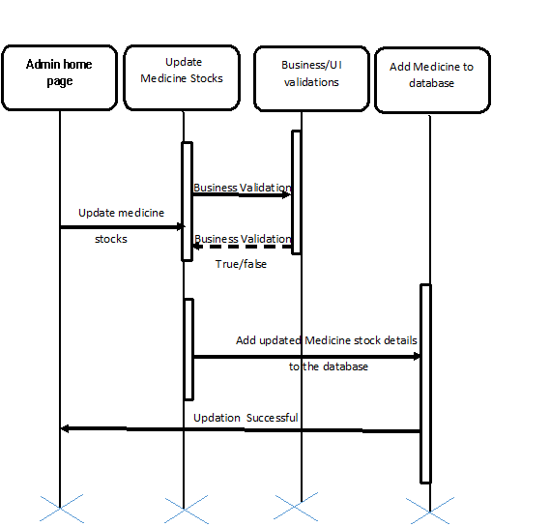

Business Rules
- A registered Admin – is able click ‘Update medicine stocks’ link in Admin home page/session and is able to view all available stocks of medicine.
- Admin should be able to edit specific medicine stocks by clicking on ‘MedicineId’ of specific Medicine in medicine stock information page followed by clicking ‘edit’ link on next page.
- Admin should be able successfully submit the updated details post successful validation with message ‘Details updated successfully’.
- Admin should be redirected to medicine details page post successful updation of medicine stock details.

UI Requirements

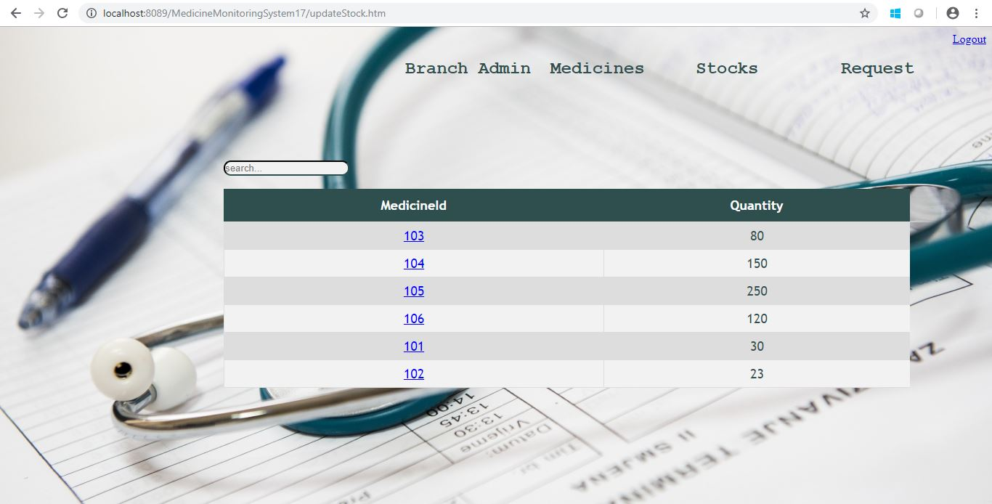



UI Field Validations
- Quantity field should be numeric and maximum length should be 3.

Use Case ‘Create branch Admin Request’

Use Case Attributes
Use Case Description:

This use case deals with creation of branch admin request. The ‘Admin’ here shall be the operator of the system and will be able to create branch admin request for medicines by clicking on ‘create branch admin request’ on its home page.

Scope:

- Creating branch Admin Request

Actors:

Admin– the operator

Trigger:

Click ‘Create Branch Admin request’ button in Admin home page.

Pre-Condition:

Admin being able to access its own home page.

Post Condition:

Admin is in its own Home page where he/she is able create branch admin request by clicking ‘create branch admin request’ link and would be able to update all necessary fields required for creating branch admin request.

Flow of Events:

Admin at Home Page →Admin clicks on ‘Create branch admin request’ link → Admin is in the Request creation page → Admin clicks on ‘create request’ link→ success message→Admin is in its home page.

Primary Scenario:
A registered Admin – is able to click on ‘create branch admin request’ link in the admin home page and is redirected to request creation page where he/she is able to update all the required fields such as branch admin id, request creation date, medicine quantity and then clicks on ‘create request’ link, on post successful validation admin is redirected to its own home page with success message ‘request generated’.

Use Case Model
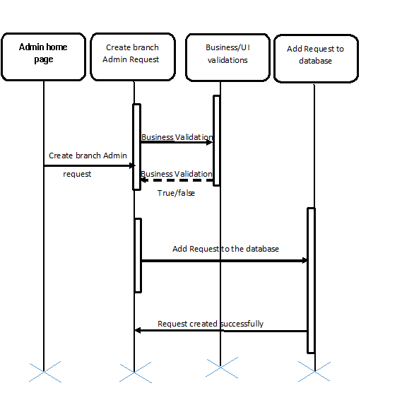

Business Rules
- A registered Admin – is able click ‘create branch admin request’ link in Admin home page/session and is redirected to request creation page.
- Admin should be able to update all the required fields.
- Admin should be able successfully submit the updated details post successful validation with message ‘Request generated’.
- Admin should be redirected to its own home page post successful creation of request.

UI Requirements

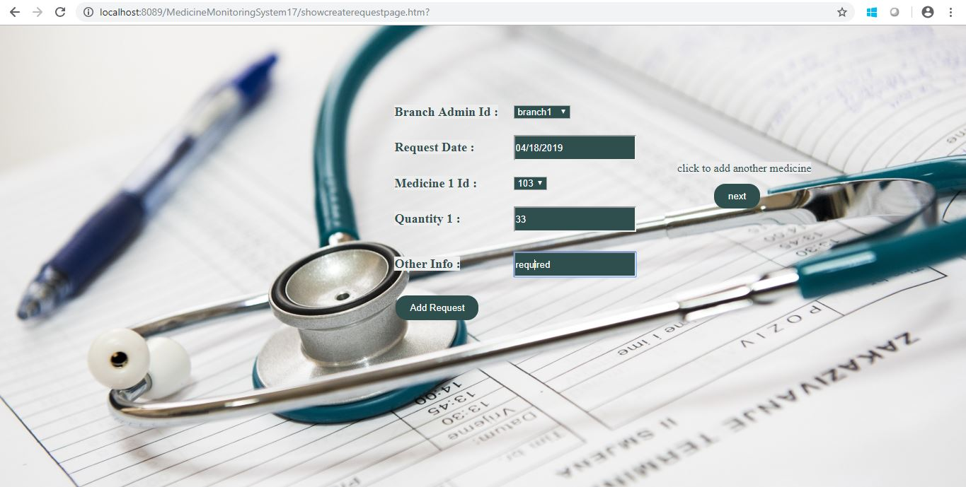

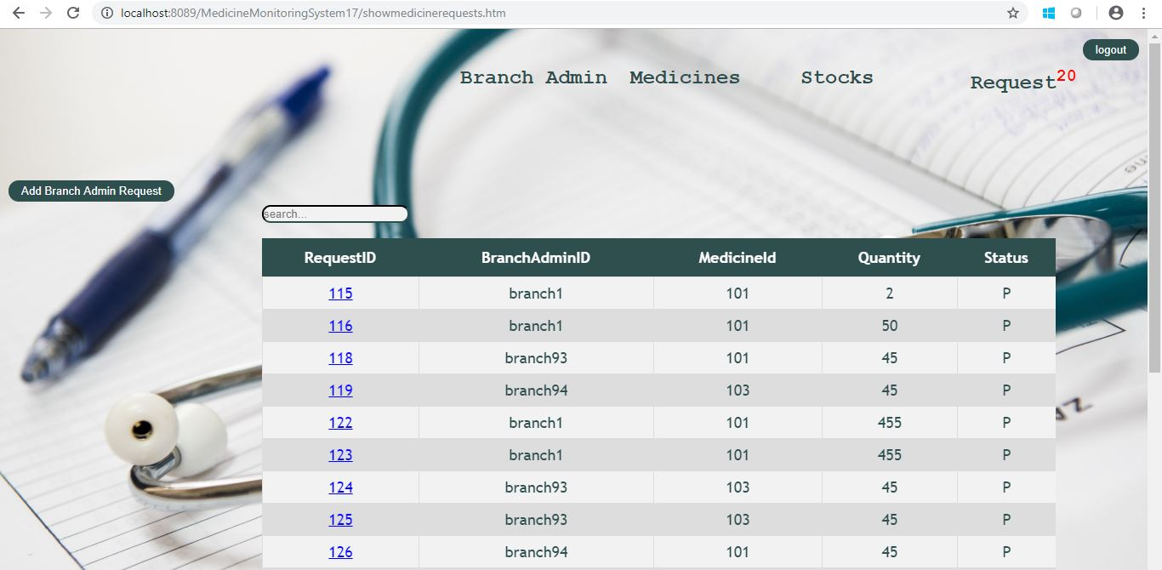

UI Field Validations
- Quantity field should be numeric and maximum length should be 3.
- Request creation date should not be past or future date.

Use Case ‘Update Branch Admin Request’

Use Case attributes
Use Case Description:

This use case deals with updation of branch admin request. The ‘Admin’ here shall be the operator of the system and will be able to update branch admin request for medicines by clicking on ‘update branch admin request’ on its home page further he/she can approve/reject requests on request updation page.

Scope:

- Updating branch Admin Request

Actors:

Admin– the operator

Trigger:

Click ‘update Branch Admin request’ button in Admin home page.

Pre-Condition:

Admin being able to access its own home page.

Post Condition:

Admin is in its own Home page where he/she is able update branch admin request by clicking ‘update branch admin request’ link and would be able approve/reject branch admin requests.

Flow of Events:

Admin at Home Page →Admin clicks on ‘Update branch admin request’ link → Admin is in the Request updation page → Admin clicks on ‘approve/reject request’ link→ success message→Admin is in its home page.

Primary Scenario:
A registered Admin – is able to click on ‘update branch admin request’ link in the admin home page and is redirected to request updation page where he/she is able to approve/reject pending requests as per the availability of medicine stocks, post successful validation admin is redirected to its own home page after successful approval/rejected message.

Use Case Model
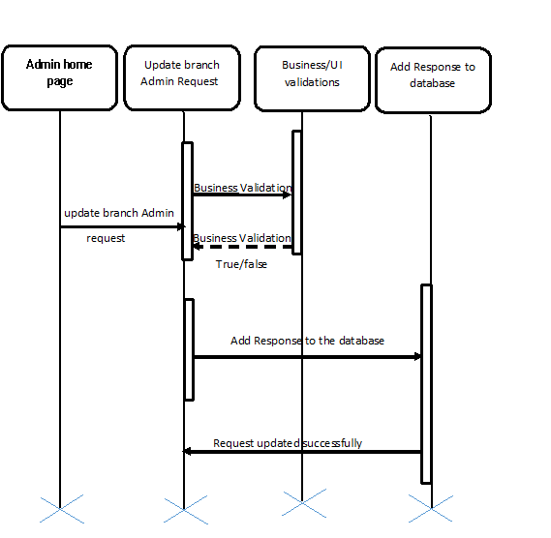

Business Rules
- A registered Admin – is able click ‘update branch admin request’ link in Admin home page/session and is redirected to request updation page.
- Admin should be able to approve/reject pending requests.
- Admin should be able successfully submit the updated details post successful validation with message ‘Request approved/rejected’.
- Admin should be redirected to its own home page post successful approval/rejection of request.

UI Requirements

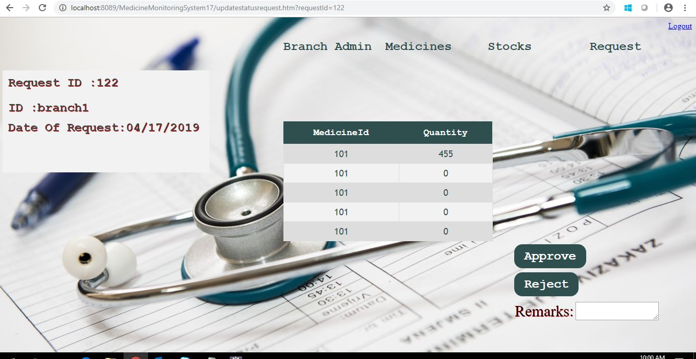

UI Field validation
- Remark field should not exceed 100 chars.

Database Design

Tables Structure
Admin Registration:
Column Name | Data Type | Length | Nulls
Amdin Id | varchar | 10 | N
Password | varchar | 10 | N
First Name | varchar | 50 | N
Last Name | varchar | 50 | N
Age | number | 2 | N
Gender | varchar | 1 | N
Contact Number | number | 10 | N
Email ID | varchar | 50 | N
Alternate Contact No. | number | 10 | Y

Branch Admin Registration:

Column Name | Data Type | Length | Nulls
Branch Admin Id | varchar | 10 | N
First Name | varchar | 50 | N
Last Name | varchar | 50 | N
Age | number | 2 | N
Gender | varchar | 1 | N
Date Of Birth | varchar | 10 | N
Contact Number | number | 10 | N
Alternate Contact Number | number | 10 | Y
Email ID | varchar | 50 | N
Branch Name | varchar | 50 | N
Address Line1 | varchar | 100 | N
Address Line2 | varchar | 100 | Y
City | varchar | 50 | N
State | number | 50 | N
Zip Code | number | 10 | N

Medicine:
Column Name | Data Type | Length | Nulls
Medicine Id | number | 8 | N
Medicine Description | varchar | 200 | N
Cure For | varchar | 100 | N
Manufacturing Company | varchar | 50 | N
Dosage | number | 3 | N
Prescribed For | varchar | 1 | N
Quantity | number | 10 | N

Branch Admin Request:
Column Name | Data Type | Length | Nulls
Request Id | number | 8 | N
Branch Admin Id | varchar | 10 | N
Request Date | varchar | 200 | N
Medicine Id1 | number | 8 | N
Quantity 1 | number | 3 | N
Medicine Id2 | number | 8 | Y
Quantity 2 | number | 3 | Y
Medicine Id3 | number | 8 | Y
Quantity 3 | number | 3 | Y
Medicine Id4 | number | 8 | Y
Quantity 4 | number | 3 | Y
Medicine Id5 | number | 8 | Y
Quantity 5 | number | 3 | Y
Other info | varchar | 200 | Y
Admin Process date | varchar | 20 | N
Admin response | varchar | 1 | N

Change Log
Version Number | Changes Made
V1.0 | Initial baseline created on <dd-Mon-yy> by <Name of Author>
 | Section No. | Changed By | Effective Date | Changes Effected
 | NA | NA | NA | NA

